ACCOUNT STRUCTURE
BLOG NAME: thegmdietplan.blogspot.com ACCOUNT NAME: Nupur_Ray_MIS6344_501
WEB PROPERTY NAME: The GM Diet Plan
VIEWS/PROFILES:
- All Website Data: No filters applied here. This contains raw data.
- Master Data: This filter will include hostname (blog) traffic only.
- Test Data: No filters applied here.
- India Data: A filter specific to country India is applied here to track data from India.
- USA Data: A filter specific to country United States is applied here to track data from USA.
USER PRIVILEGES:
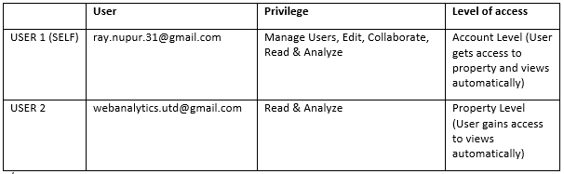
SEGMENTS:
Segment Name: E - mail Campaign
Conditions: Traffic Sources: Campaign contains nupurray, Medium contains email, Source contains google.
URL USED FOR EMAIL CAMPAIGN:
https://thegmdietplan.blogspot.com/?utm_medium=email&utm_source=google&utm_campaign=nupurray
OVERVIEW AFTER APPLYING EMAIL CAMPAIGN SEGMENT:
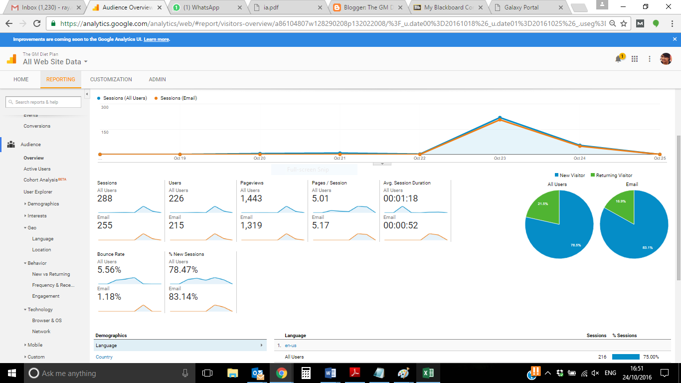
USER ENGAGEMENT AND TRAFFIC FROM VARIOUS CHANNELS:
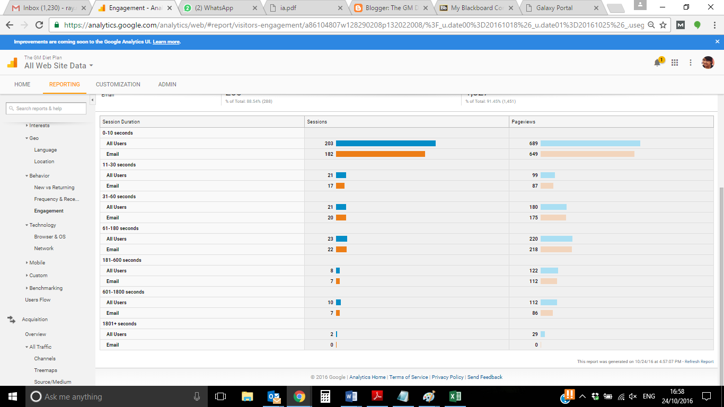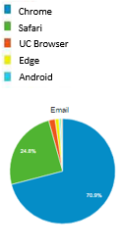

Based on the Engagement reports the following observations can be made:
- Traffic from Email medium is less as compared with other from which we can recommend putting more efforts for marketing site via email medium.
- From user engagement screenshot we can infer very less number of people access site for more than 180 seconds which is very low. We can recommend putting more user engaging content.
- From Geo analysis, we can conclude majority of traffic is from US and India only. We can recommend promotion of web site in different countries.
- Bounce rate is 5.5% which tells us that landing page or the looks of site is very effective for user engagement.

NEW VS RETURNING VISITORS (EMAIL CAMPAIGN): 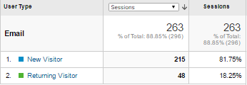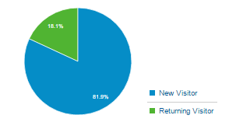
Based on the New vs Returning Visitors report the following observations can be made:
- The percentage of New Visitors is higher than the Returning Visitors which indicates the success of campaigning but due to less returning users we can conclude that the blog content lacks interest in the topic.

FREQUENCY AND RECENCY (EMAIL CAMPAIGN):
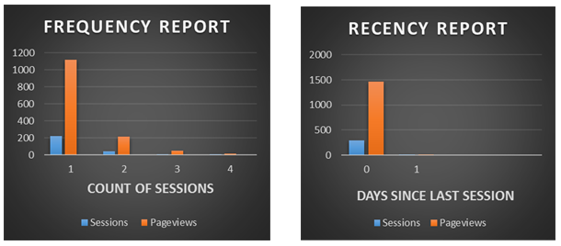
Based on the Frequency and Recency reports, the following observations can be made:
- Maximum contribution of pageviews (1342) are from the band containing new users (count of sessions = 1)
- Returning users might have less pageviews as they will only look directly for latest content in the blog.
- The recency report suggests that majority of sessions are from users whose days since last visit=0. This can be misleading as it will include new users. Better analysis can be performed by excluding new users using an advanced segment

